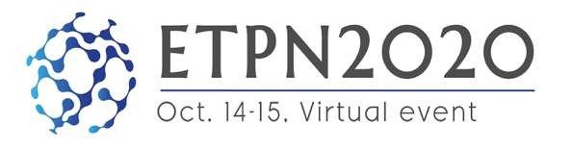

Abstract template to present your work during ETPN2020

IMPORTANT:
- The Pitch me up! session (on Oct. 15) is opportunity to give a short talk and present your innovative Nanomedicine projects in translation to market (TRL3-8).
- Please submit abstract (.pdf only) by sending it to: abstract@etpn2020.eu
- For any complementary info, see the ETPN2020 abstract guidelines.
- Deadline for abstract submission for the Pitch me Up session: 2nd of October, 2020

Author name(s)* :
Position / Job:
Organization / company**:
City (Country):
Email contact address :

Abstract title:
(max. 250 characters incl. spaces)
Abstract body:
(max. 2500 characters incl. spaces)
Your abstract may additionally contain one important figure and references. Use the space below if you want to include one figure.

(INSERT FIGURE)

Fig. 1 Figure Caption

Acknowledgements

Acknowledgement text.

References:
[1] “Article Title”, Authors, Name of Journal Vol. Number, page (year).
[2] Authors, Title of Book, Publisher, City (Year).
[3] Authors, Conference, Dates, City, Country, Page (Year).

*if several authors, please write in bold the name of the person who will give the presentation during the virtual event ETPN2020
**of the person who will give the presentation during the virtual event ETPN2020

